7 Creating a Smooth Transition Between Clips
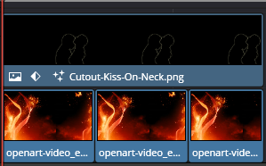
I only had short clips, and I really needed it to be longer, so I put a string of clips next to each other. But going from one clip to another was like a speed bump. I needed to have as smooth transition between each clip.
Smooth Transitions for Background Video Clips
- In the Edit page timeline, look at your bottom video track (V1)
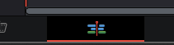
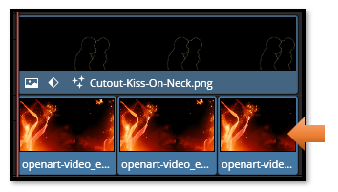

- Click on the cut/seam between the first two background clips
  - Make sure you're clicking on the V1 track, not the couple image above

Note-If you get this error, it means you did not overlap your clips, or you did not have DaVinci trim them slightly to provide for the overlap. You can do either way, either drag the second clip slightly to the left where it overlaps the first clip, but it is easier to have Davinci trim the clips for you it will shorten them slightly.
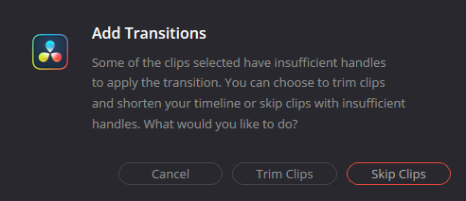
Now you should see the white rectangle which tell you, step 3, should work
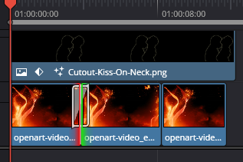

- Press Ctrl + T to add a Cross Dissolve
  - This blends the particle effects between clips
After adding, you can select the white rectangle between frames to select the transition and then choose you Cross Dissolve here in the Inspector on the right side of the screen.
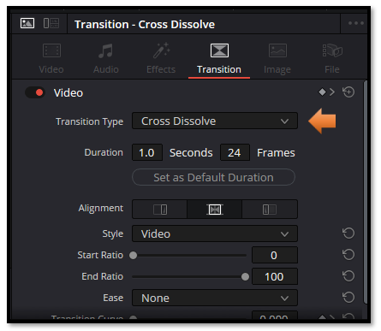
- Repeat for each cut between your background clips on V1
- Make the transitions longer:
  - Click on the transition
  - Drag the edges to 45-90 frames (1.5-3 seconds)
  - Longer transitions hide the jumps better

How to Tell what Transition you have Applied
- Click on the small white rectangle between your clips on the V1 timeline
  - Those white boxes between the background clips are your transitions
- Look at the Inspector panel (top right)
  - It will show the transition name and settings
  - You'll see either "Cross Dissolve" or "Dip To Color Dissolve"
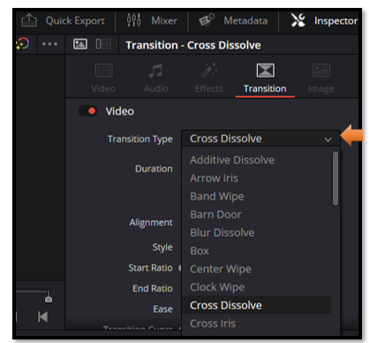

- Hover your mouse over the transition on the timeline
  - A tooltip should pop up showing the transition name
What You're Seeing:
- Red box around "Dip To Color Dissolve" in the left panel = That transition is currently selected in the library
- Red marks in Cross Fade = Recent/favorite indicators
- What's actually on your timeline = Check by clicking the transition itself

